2024 Congressional Art Competition

Student Information & Release Form

PLEASE PRINT CLEARLY. THIS INFORMATION IS USED FOR CERTIFICATES AND AWARDING SCHOLARSHIPS.

INCOMPLETE FORMS WILL NOT BE ACCEPTED.

MEMBER/DISTRICT INFORMATION

MEMBER OF CONGRESS NAME: Austin Scott | STATE & DISTRICT: GA - 08

STUDENT INFORMATION


NAME: ☐ Mr. ☐ Ms. |  | GRADE:
STREET ADDRESS:
CITY: | STATE: | ZIP:
MAILING ADDRESS (IF DIFFERENT):
STUDENT EMAIL: | STUDENT PHONE (CELL):
PARENT OR GUARDIAN NAME(S):
PARENT PHONE (HOME): | PARENT PHONE (WORK or CELL):
PARENT EMAIL:
SCHOOL
SCHOOL NAME:
STREET ADDRESS:
CITY: | STATE: | ZIP:
ART TEACHER NAME:
ART TEACHER PHONE: | ART TEACHER EMAIL:

ART COMPETITION ENTRY
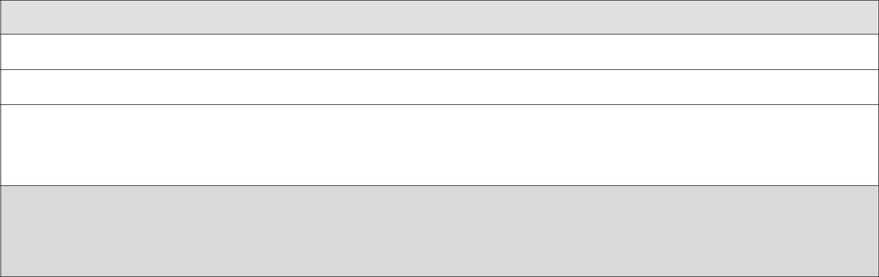

TITLE OF ENTRY:

MEDIUM:

DESCRIPTION:

Please include a detailed description of the artwork, clearly identifying the major elements of the piece.

For office use only:

FRAMED DIMENSIONS: Height:________ inches Width: _______inches Depth: ______ inches See official guidelines for framed size and artwork weight restrictions.

PLEASE COMPLETE THE RELEASE FORM ON PAGE 2. PAGE 1 OF 2

2024 Congressional Art Competition

Student Information & Release Form

(CONTINUED FROM PAGE 1)


STUDENT NAME: | STATE & DISTRICT: GA - 08
TITLE OF ENTRY:

ORIGINALITY CERTIFICATION


I hereby certify that, to the best of my knowledge, the art entry described above is an original work of authorship by the undersigned student and that it is not copied from, nor does it include, any other person’s copyrighted work.
 | STUDENT SIGNATURE |  |  | ART TEACHER SIGNATURE

ARTWORK RELEASE


We, the undersigned, represent that the art entry described above is an original work of authorship personally created by the undersigned student to which the student is entitled copyright protection. In consideration for the acceptance of the art entry by the Member of Congress designated above in An Artistic Discovery (the Congressional Art Competition sponsored by the U.S. House of Representatives) and intending to be legally bound hereby, the undersigned grant the Member and the House the right to publicly display the art entry, if it is selected for display, in accordance with the rules of the Art Competition. The undersigned grant the Member, the House, their employees and agents, the United States, and the Congressional Institute, Inc., and its employees, the right to reproduce the art entry for any non-commercial purpose. The undersigned further release the Member, the House, their employees and agents, the United States, and the Congressional Institute, Inc., and its employees, from any and all liability for damage, loss, or misappropriation of the art entry during and subsequent to the Art Competition. The undersigned further agrees to indemnify, hold harmless and defend the Member, the House, their employees and agents, the United States, and the Congressional Institute, Inc., and its employees, against any and all claims of any nature whatsoever, including, but not limited to, claims of copyright infringement, by any party whatsoever, arising out of or in any way related to the submission of the art entry in the Art Competition.
 | STUDENT SIGNATURE |  |  | PARENT/GUARDIAN SIGNATURE (IF UNDER 18)

PAGE 2 OF 2

